**FORM 16**

|  |  |
| --- | --- |
|  |  |
|  |  |

[See Rule31(1)(a)]

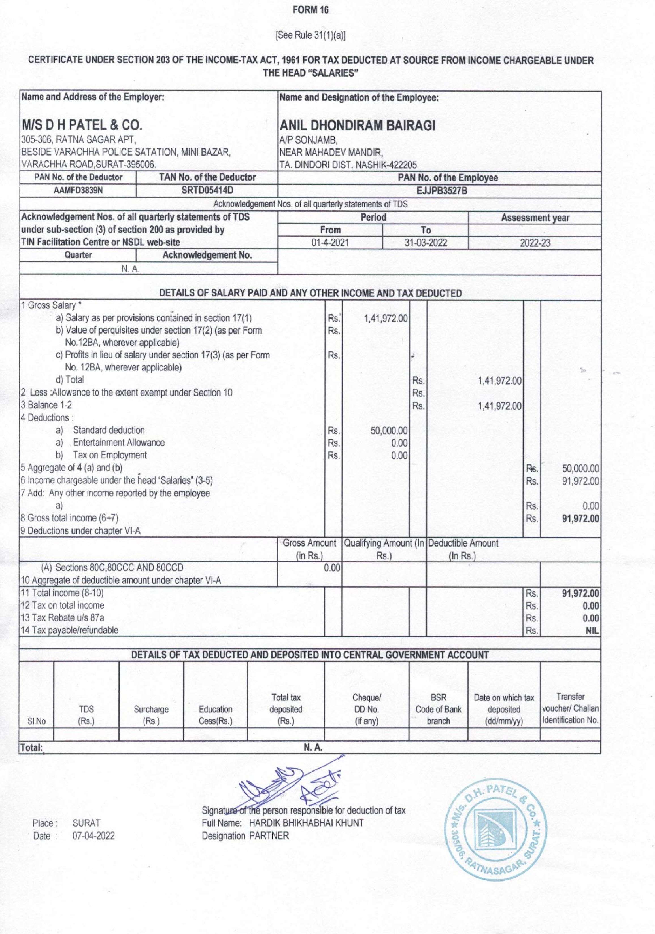**CERTIFICATE UNDER SECTION 203 OF THE INCOME-TAX ACT, 1961 FOR TAX DEDUCTED AT SOURCE FROM INCOME CHARGEABLE UNDER THE HEAD "SALARIES"**

|  |  |  |  |  |  |  |  |  |  |  |  |  |  |  |
| --- | --- | --- | --- | --- | --- | --- | --- | --- | --- | --- | --- | --- | --- | --- |
| **Name and Address of the Employer:**  **M/S D H PATEL & CO.**  305-306, RATNA SAGAR APT,  BESIDE VARACHHA POLICE SATATION, MINI BAZAR, VARACHHA ROAD,SURAT-395006. | | | | | | **Name and Designation of the Employee:**  **ANIL DHONDIRAM BAIRAGI**  A/P SONJAMB,  NEAR MAHADEV MANDIR,  TA. DINDORI DIST. NASHlK422205 | | | | | | | | |
| **PAN No. of the Deductor** | | | **TAN No. of the Deductor** | | | **PAN No. of the Employee** | | | | | | | | |
| **AAMFD3839N** | | | **SRTD05414D** | | | **EJJPB3527B** | | | | | | | | |
| Acknowledgement Nos. of all quarterly statements of TDS | | | | | | | | | | | | | | |
| **Acknowledgement Nos. of all quarterly statements of TDS under sub-section (3) of section 200 as provided by**  **TIN Facilitation Centre or NSDL web-site** | | | | | | **Period** | | | | | | **Assessment year** | | |
| **From** | | | **To** | | |  | | |
| 01-04-2020 | | | 31-03-2021 | | | 2021-22 | | |
| **Quarter** | | | **Acknowledgement No.** | | |  | | | | | | | | |
| **N.A.** | | | | | |
| **DETAILS OF SALARY PAID AND ANY OTHER INCOME AND TAX DEDUCTED** | | | | | | | | | | | | | | |
| 1. Gross Salary *    1. Salary as per provisions contained in section 17(1)    2. Value of perquisites under section 17(2) (as per Form No.12BA, wherever applicable)    3. Profits in lieu of salary under section 17(3) (as per Form No. 12BA, wherever applicable)    4. Total 2. Less :Allowance to the extent exempt under Section 10 3. Balance 1-2 4. Deductions :    1. Standard deduction    2. Entertainment Allowance    3. Tax on Employment 5. Aggregate of 4 (a) and (b) 6. Income chargeable under the head "Salaries" (3-5) 7. Add: Any other income reported by the employee   a)   1. Gross total income 2. Deductions under chapter VI-A | | | | | | | Rs.  Rs.  Rs.  Rs.  Rs.  Rs. | 1,44,000  0.00  0.00  0.00 | | Rs.  Rs.  Rs. | 1,44,000  1,44,000 | | Rs.  Rs.  Rs.  Rs. | 0.00  0.00  0.00  **1,44,000** |
|  | | | | | | Gross Amount  (in Rs.) | | Qualifying Amount (In RS.) | | | Deductible Amount  (In Rs.) | | | |
| (A) Sections 80C,80CCC AND 80CCD  10 Aggregate of deductible amount under chapter VI-A | | | | | | 0.00 | |  | | |  | | |  |
| 1. Total income (8-10) 2. Tax on total income 3. Tax Rebate UIs 87a 4. Tax a able/refundable | | | | | | |  |  | |  |  | | Rs.  Rs.  Rs.  Rs. | **1,44,000**  **0.00**  **0.00**  **NIL** |
|  | | | | | | | | | | | | | | |
| **DETAILS OF TAX DUCTED AND DEPOSITED INTO CENTRAL GOVERNMENT ACCOUNT** | | | | | | | | | | | | | | |
| Sl.No | TDS  (Rs.) | Surcharge  (Rs.) | | Education  Cess(Rs.) | Total tax  Deposited  (Rs.) | | Cheque/  DD No.  (if any) | | | BSR  Code of Bank  branch | | Date on which tax deposited  (dd/mm/yy) | | Transfer voucher/ Challan Identification No. |
|  |  |  | |  |  | |  | | |  | |  | |  |
| **Total:** **N.A.** | | | | | | | | | | | | | | |